**Module-3: Roles Assignment 3**

**Problem Statement:**

You work for XYZ Corporation, to maintain the security of the AWS Account and the resources you have been asked to implement a solution that can help easily recognize and monitor the different users.

**You have been asked to:**

1. Create a Role which only lets Dev1 and Dev2 from task 1 to have complete access to VPCs and DynamoDB.

2. Login into Dev1 and shift to the role to test out the feature.

***Problem 1 Solution:*** *Create a Role which only lets Dev1 and Dev2 from task 1 to have complete access to VPCs and DynamoDB.*

**Step 1:** In the “**AWS Console”, Search** the **“IAM”** & **go** tothe **“IAM> Roles”.**

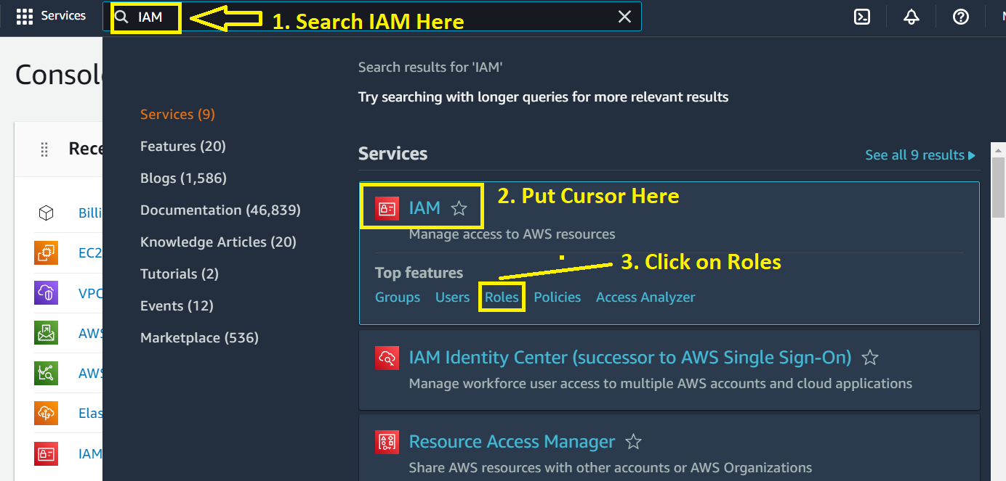

**Step 2: Click** on the **“Create Role”** in the **blue button**.

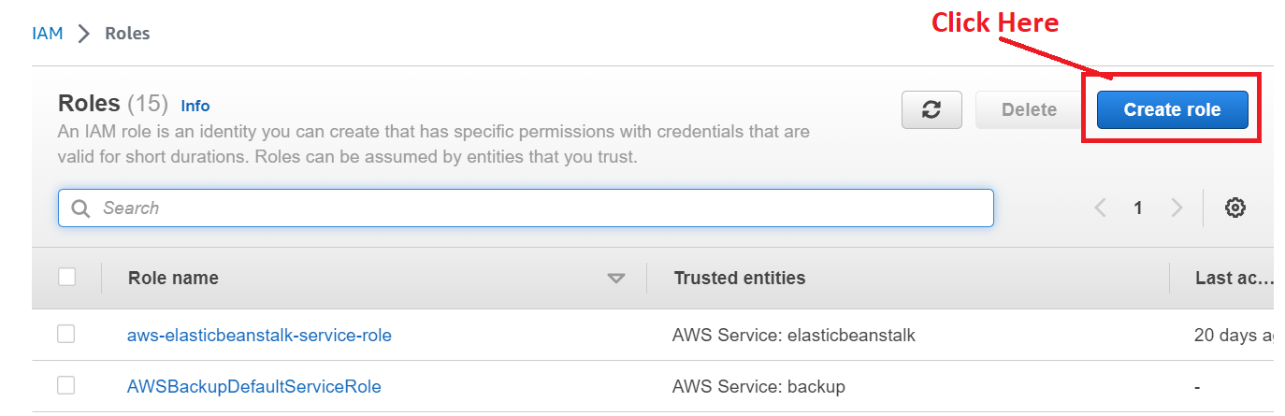

**Step 3:** Inthe **“Trusted Entity Type”,** Choose the **“AWS Account”. Click** on the **“Next”**.

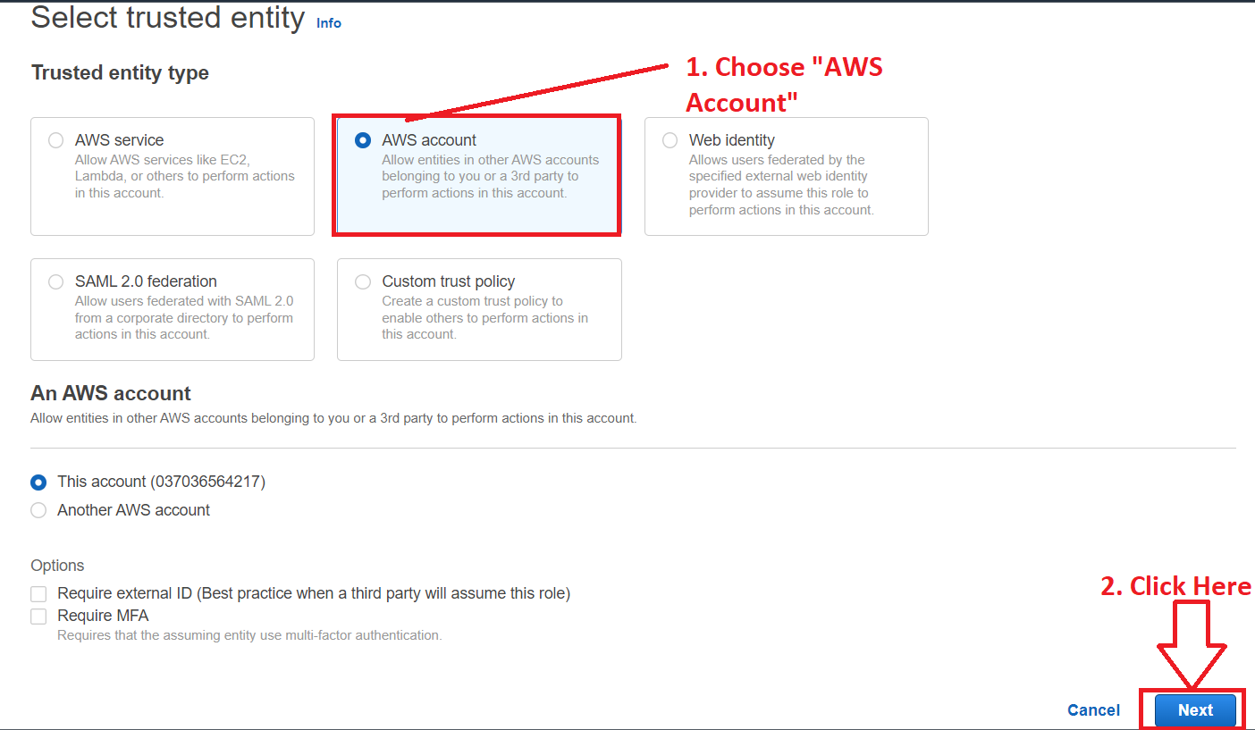

**Step 4: In** the **“Permission policies”, choose** the **“VPC”** & **press “Enter”** from the **keyboard.**

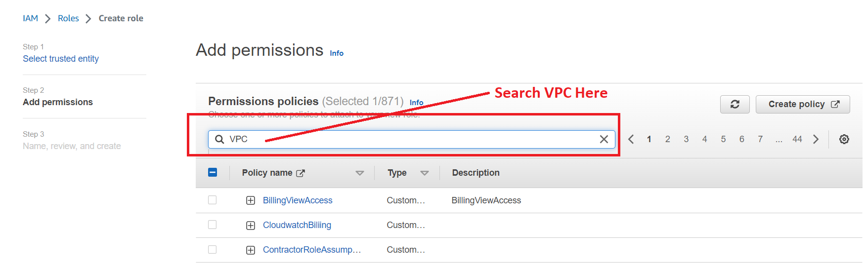

**Step 5: Choose** the **“Policy name”** asthe **“AmazonVPCFullAccess”.**

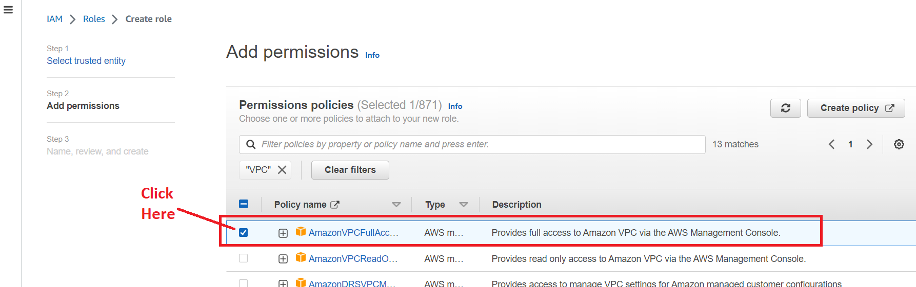

**Step 6: After** choosing **the “AmazonVPCFullAccess”, click** onthe **“X” sign** to **remove** the **“VPC”.**

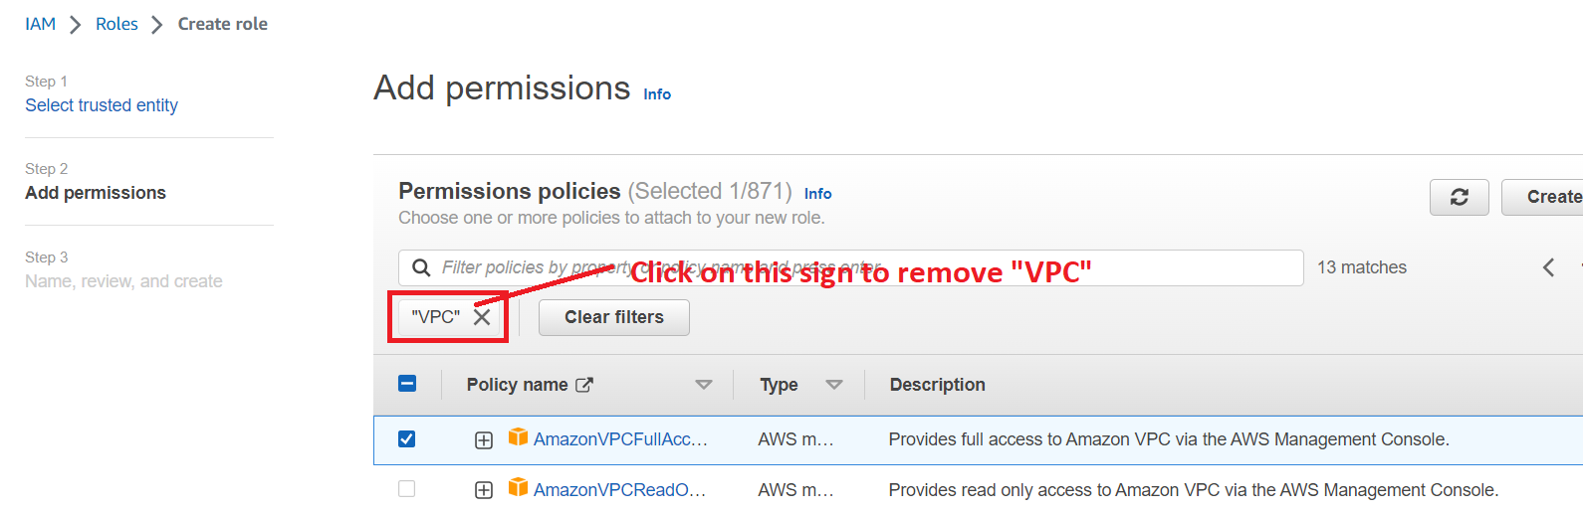

**Step 7: In** the **“Permission policies”, search** the **“DynamoDB”** service& **press “enter”** fromthe **keyboard.**

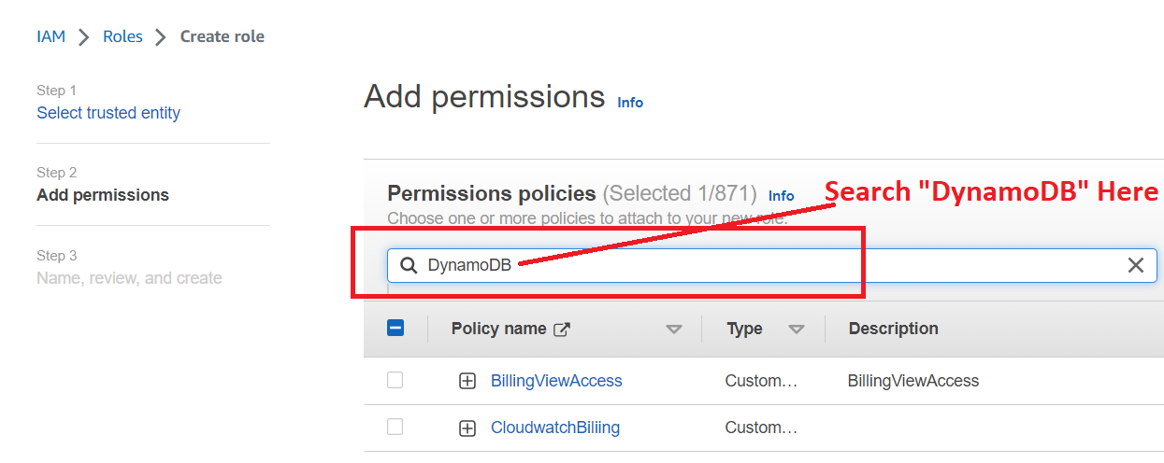

**Step 8: Choose** the **“AmazonSynamoDBFullAccess”** & **click** onthe **“Next”.**

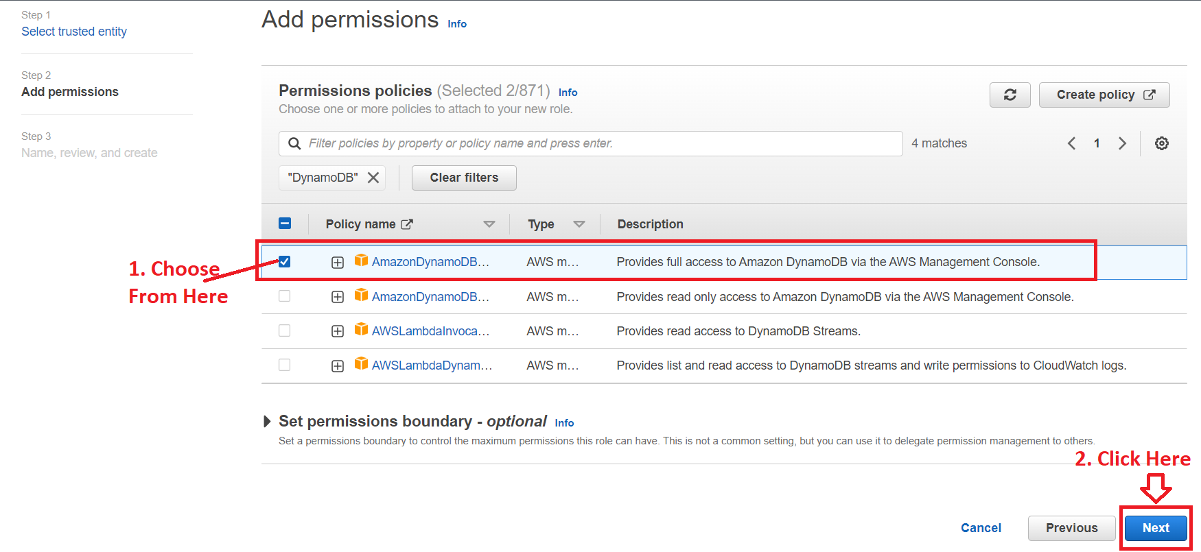

**Step 9: We** put the **“Role name”** as **VPCDynamoDB** because **we** providethe **full access** of **VPCDynamoDB** to this **role.**

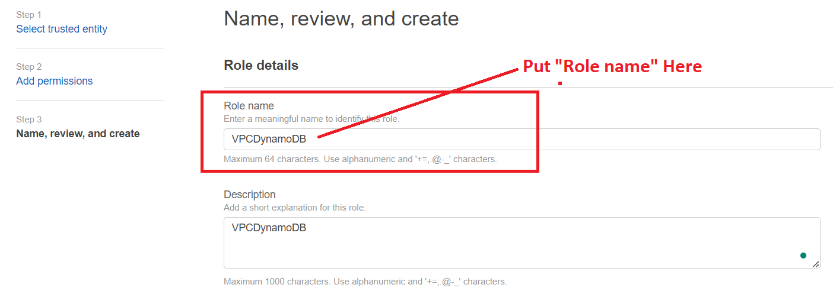

**Step 10: Scroll Down** & **click** onthe **“Create role”.**

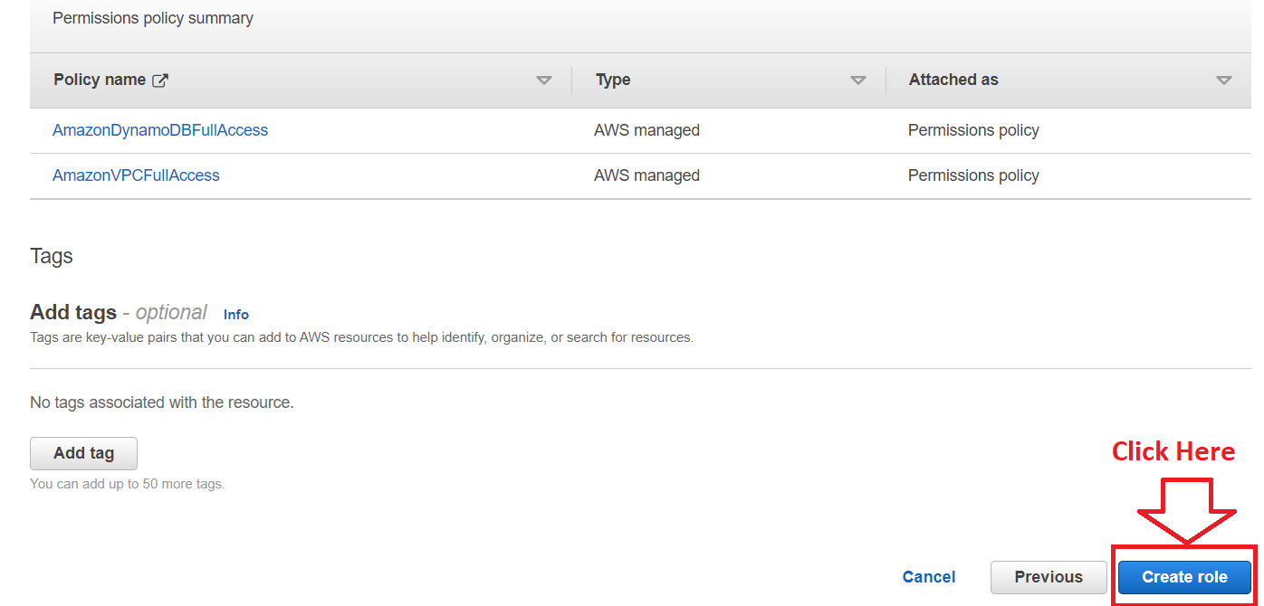

**Step 11: The role “VPCDynamoDB”** will be **successfully created.**

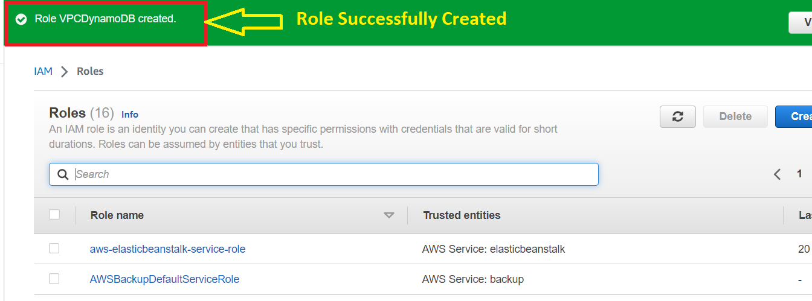

**Step 12: Click** onthe **“View role”.**

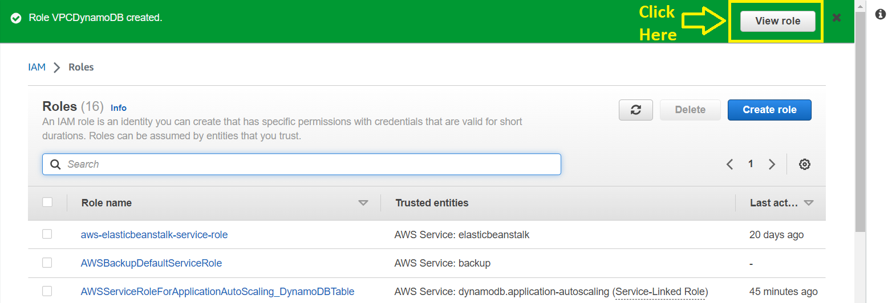

**Step 13: Go** tothe **“Trust Relationship”** & **click** onthe **“Edit trust policy”.**

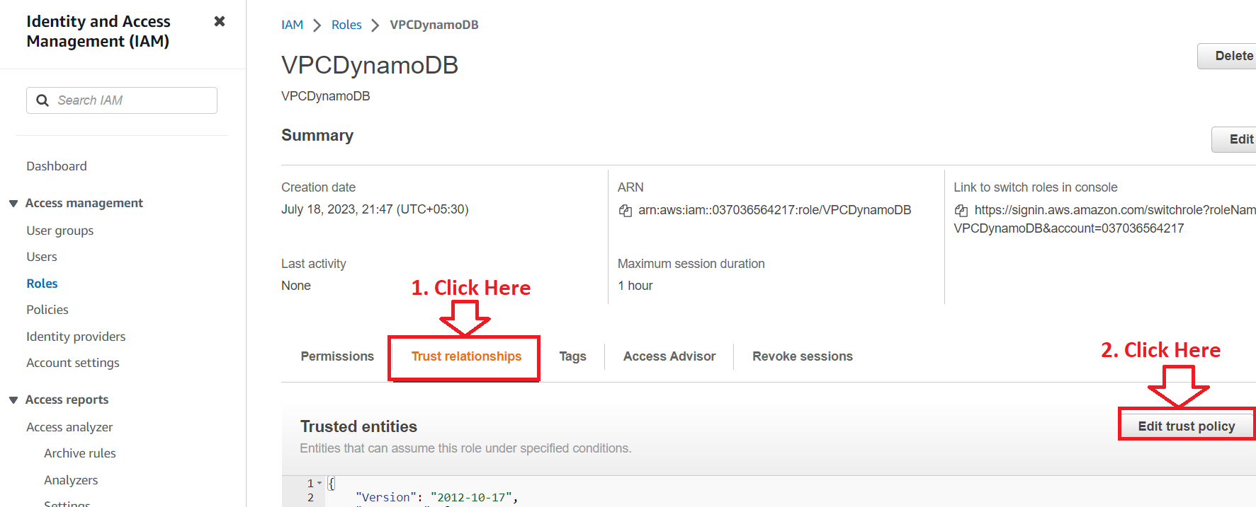

**Step 14: In** the **“Statement”, paste** the **ARN** of **Dev1** & **Dev2 user** to **access** this **role policy.**

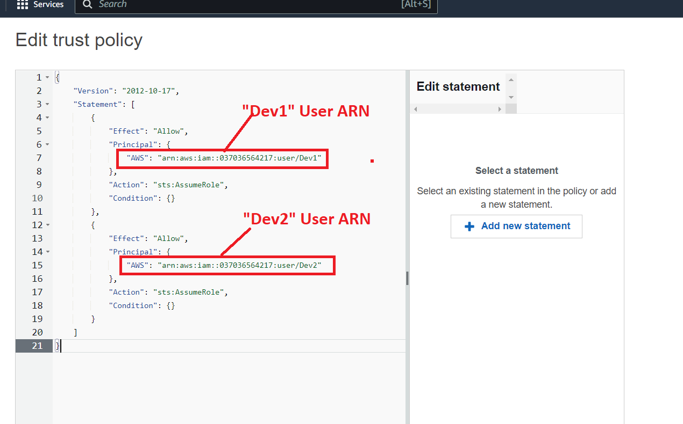

**Step 15: Click** on the **“Update policy”.**

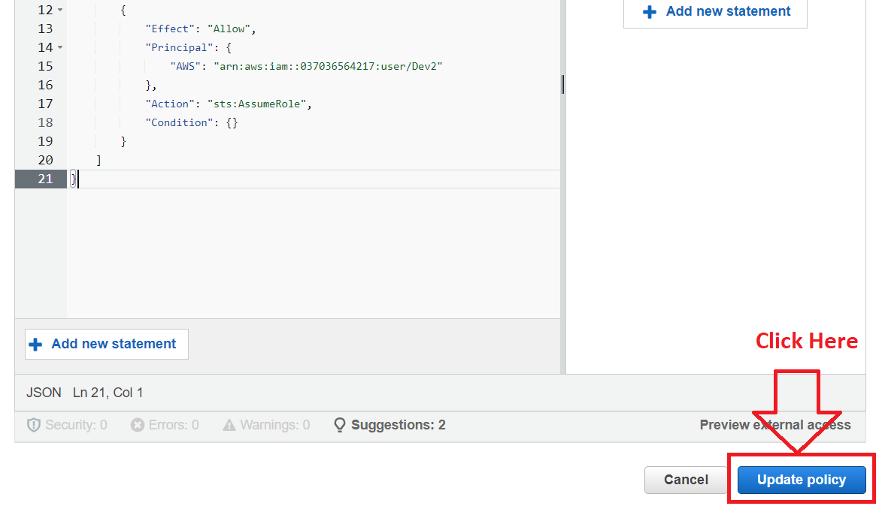

**Step 16: The “Trust Policy”** will be **successfully updated. Now, you** can **test** this **role** via **“Dev1” & “Dev2”** users**.**

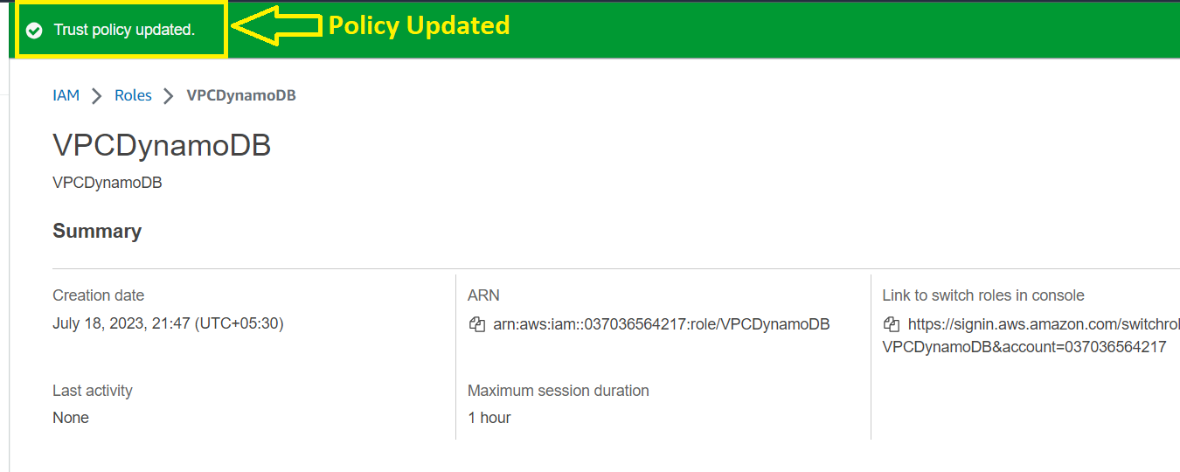

***Problem 2 Solution:*** *Login into Dev1 and shift to the role to test out the feature.*

**Step 1: Login** into **the “AWS console”** usingthe **“First User login credentials”** like this;

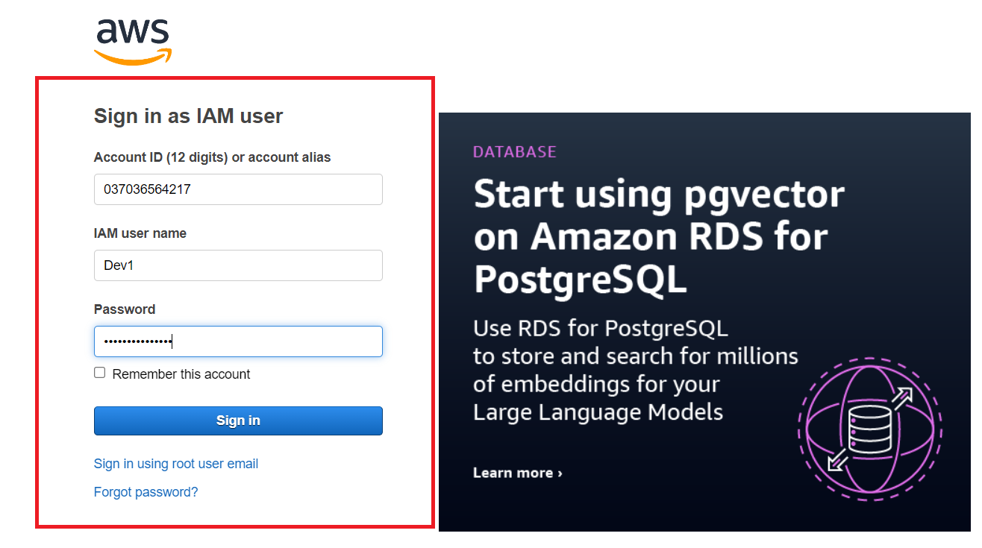

**Step 2: Now, we** will **shift** to the **VPCDynamoDB role** to **test both** the **VPC & DynamoDB** functionalities**.**

**Click** on **Dev1@0370-365-642-17** & **click** on the **“Switch Role”.**

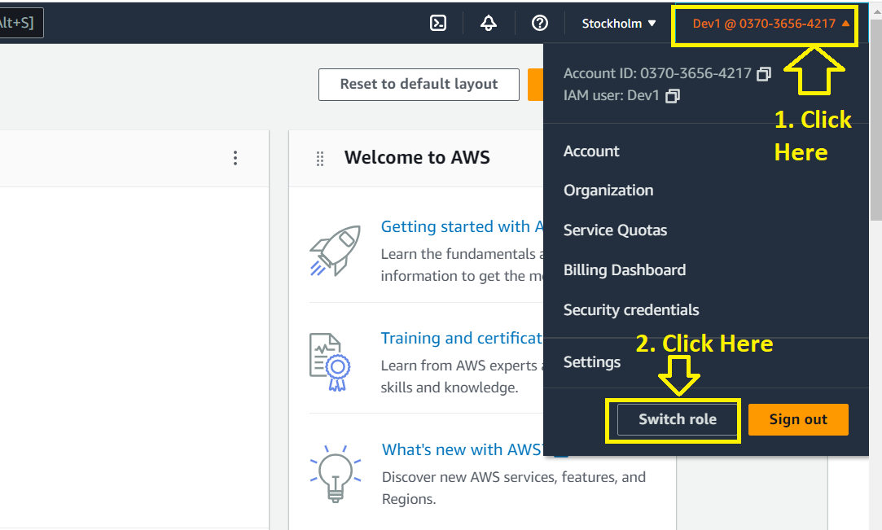

**Step 3: Click** onthe **“Switch Role”.**

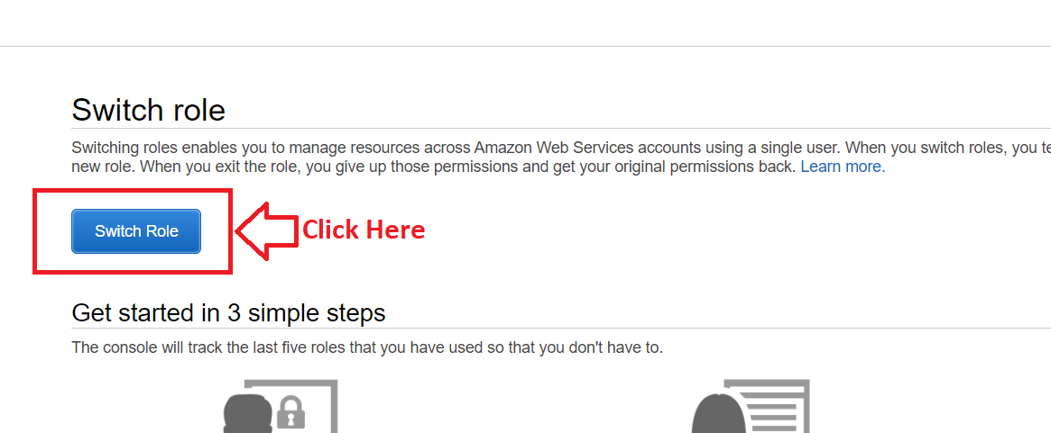

**Step 4: Fill the below options like this;**

**Account –** 037036564217

**Role –** VPCDynamoDB

**Display Name-** VPC_DynamoDBTest

**Click** on the “**Switch Role”**.

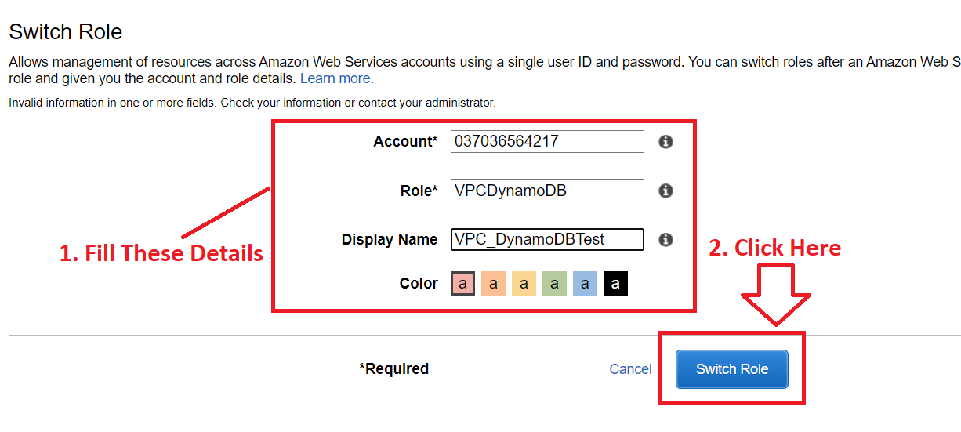

**Step 5: Now, you** can **test out** the **feature. First, we** will **change** the **region** from **Stockholm** to **Mumbai. Click** on the **“Stockholm”** & **we** will **choose** the **“Asia Pacific (Mumbai) ap-south-1”** as our **Region.**

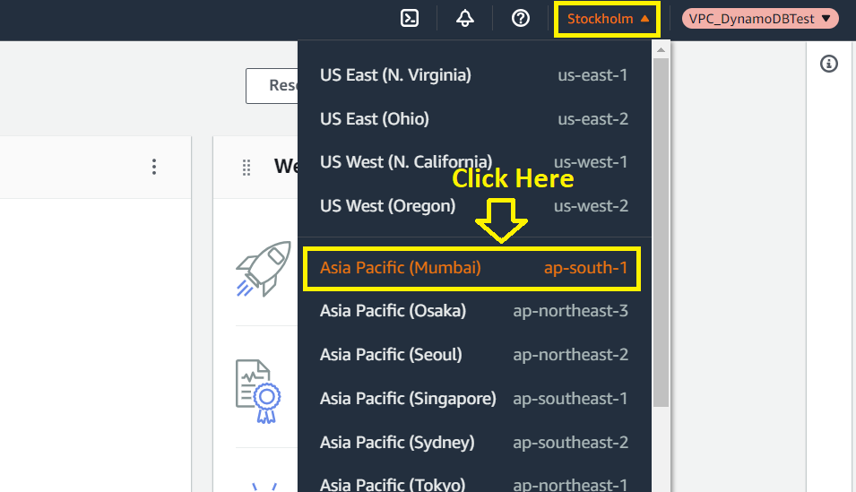

**Step 6: Now, we** will **test out** the **VPC & DynamoDB** functionalities. **First, we** will search **the “VPC” in the search bar, click** on the “**VPC”.**

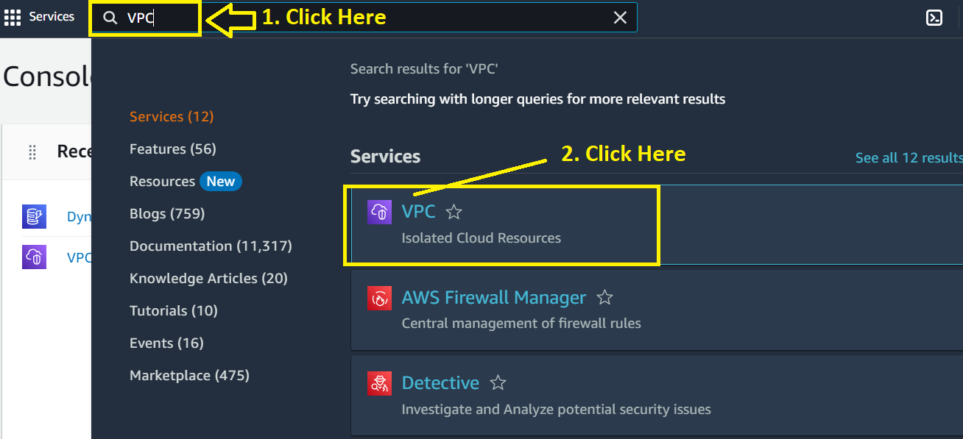

**Step 7: In** the **“VPC”, all** the **VPC functionalities** are **showing. It means, you** can **perform** allthe **“VPC” related activities** in this **account. Click** on the “**Create VPC”** button.

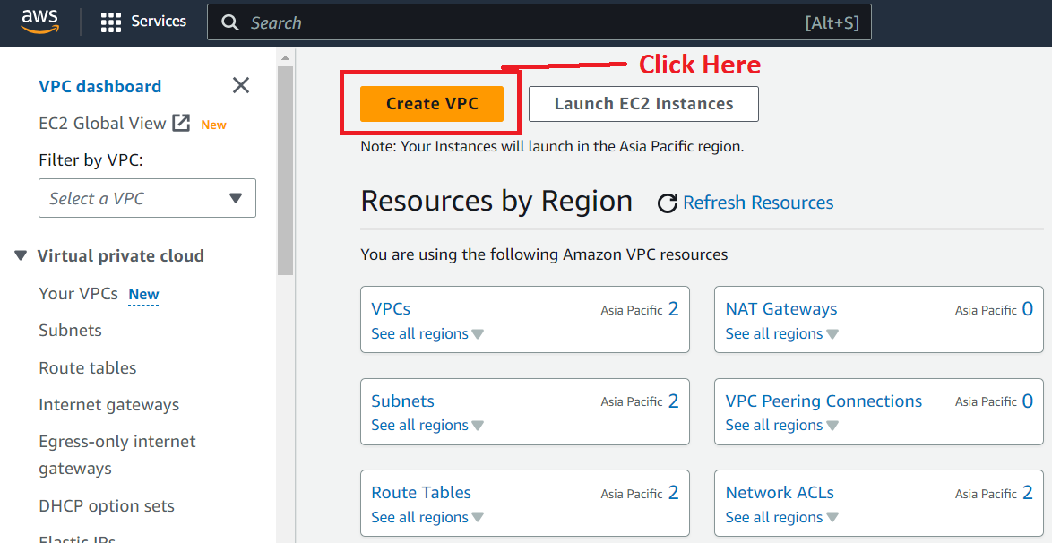

**Step 8: Choose the following options here;**

**Resource to create -** VPC only

**Name tag – optional:** my-vpc-demo

**IPv4 CIDR block** – IPv4 CIDR Manual Input

**IPv4 CIDR** – 10.0.0.0/24

Remain the other default settings as it is.

**Click** onthe **“Create VPC”.**

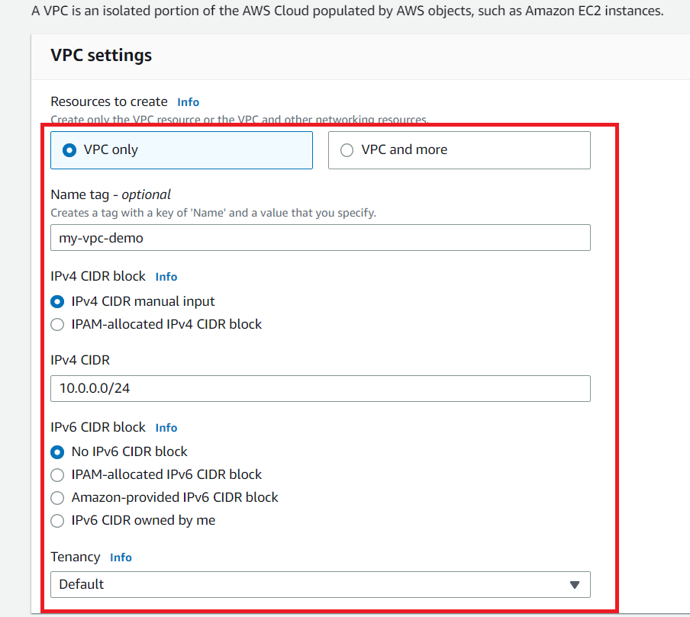

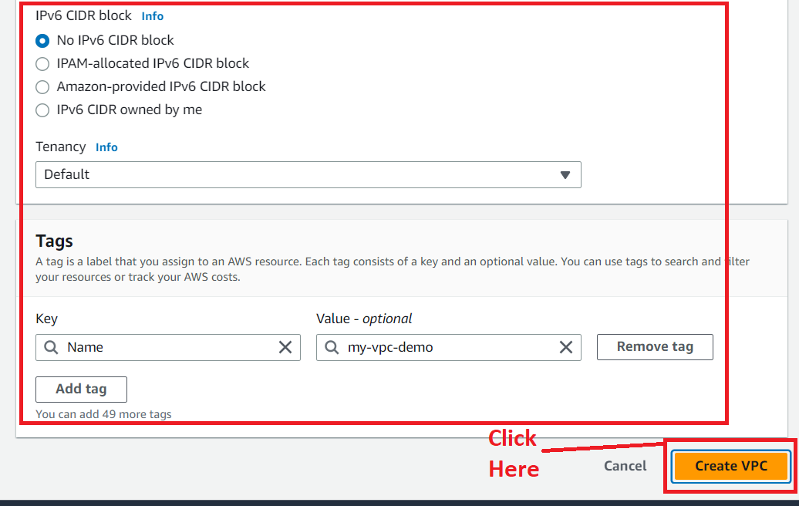

**Step 9: The “VPC [my-vpc-demo]”** will be **created successfully.**

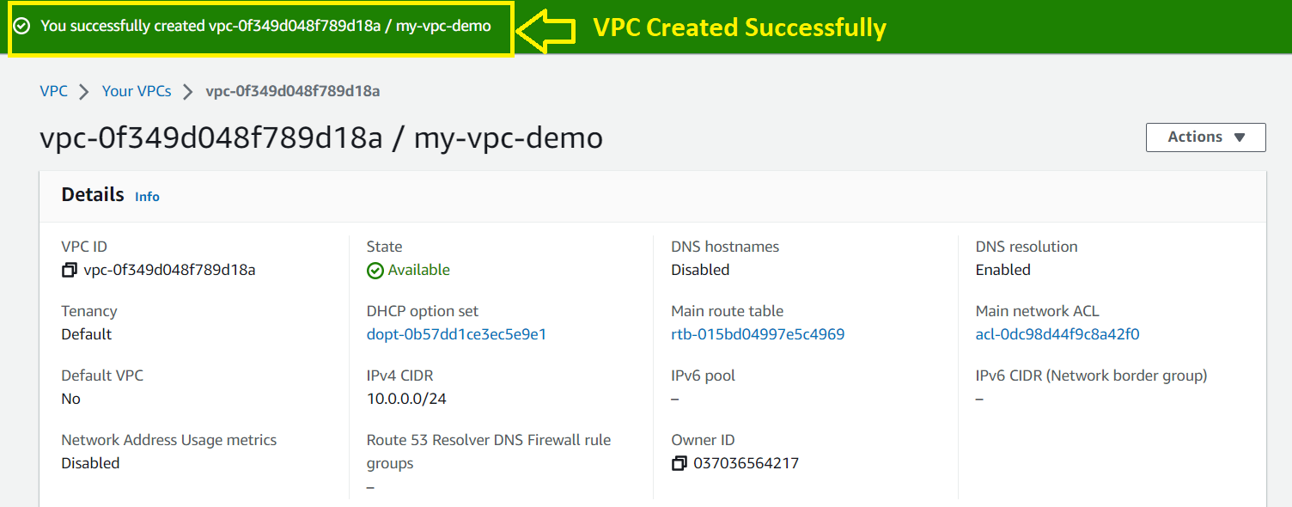

**Step 10: Now, go back** tothe **“VPC”** & **search** the **“DynamoDB”** inthe **search section** of **the “Services”. Click** on **the “DynamoDB”.**

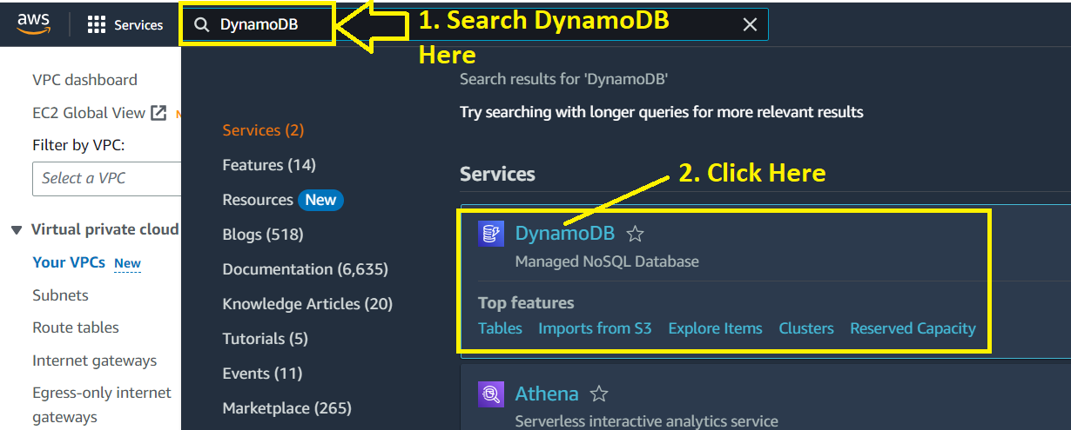

**Step 11: Click** on the **“Create Table”.**

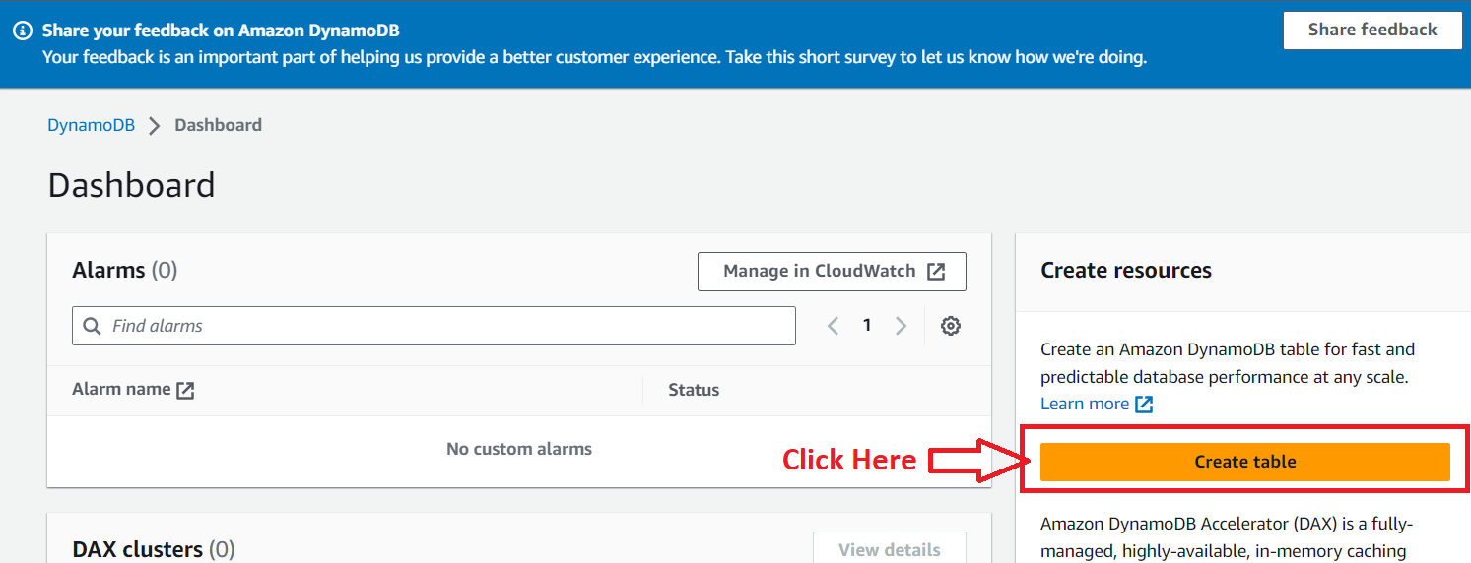

**Step 12: Choose the following options here for testing,**

**Table Name –** Demo_Table

**Partition Key – Demo**

**Click** onthe **“Create Table”.**

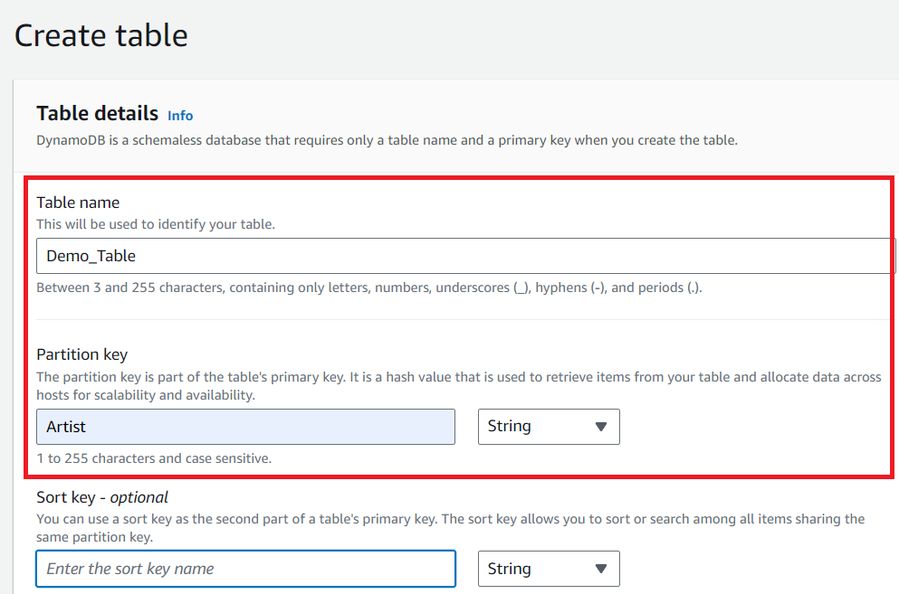

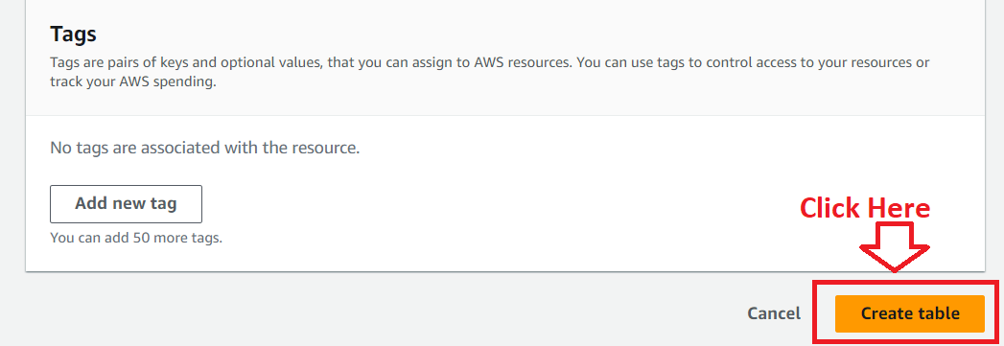

**Step 13:** Your **table** will be **successfully created**. Now, you can **add** the **columns & columns entries** here.

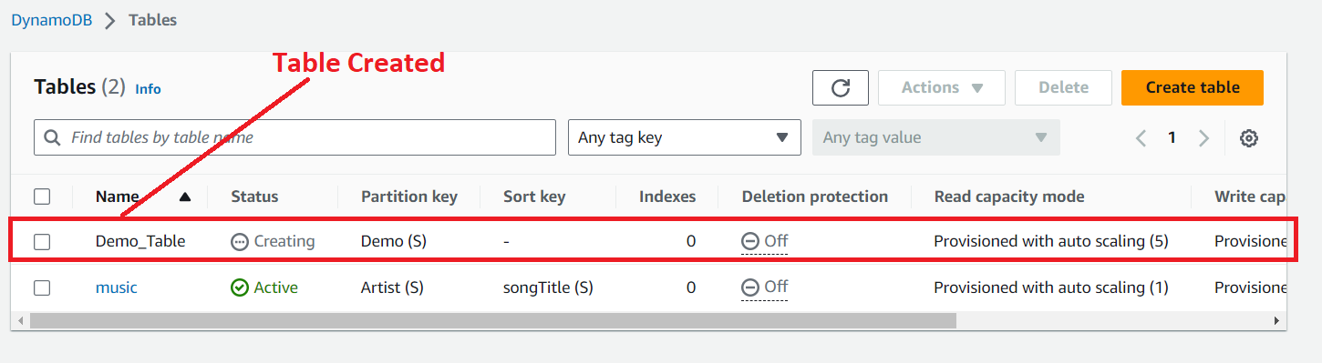

**Step 14:** **Click** on the “**Demo_Table”**.

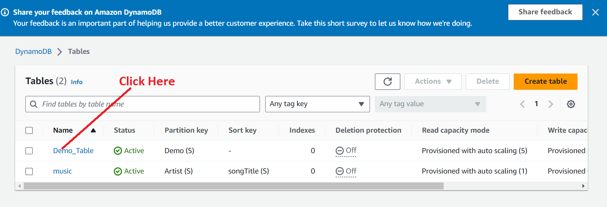

**Step 15: Click** onthe **“Explore table items”.**

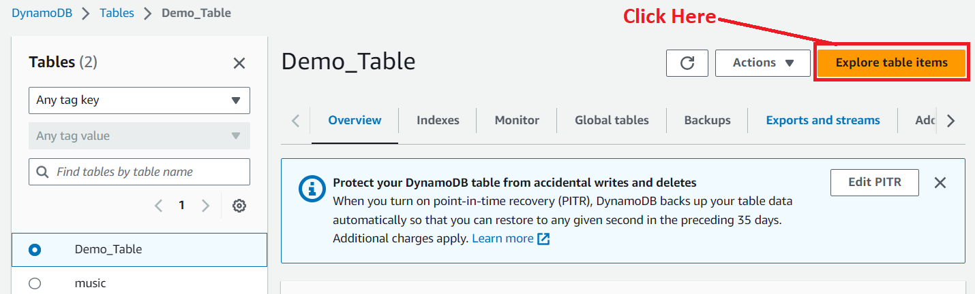

**Step 16: Go** to the “**Create item”**.

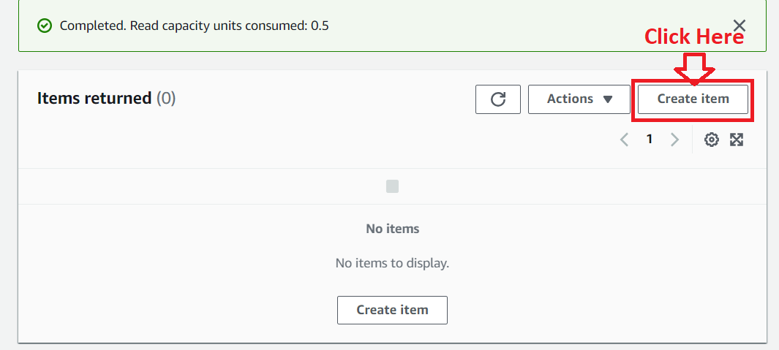

**Step 17: In** the **“Demo”** attribute**, we** will **put** the **value** as **“Hello”. Click** on the **“Add new attribute>String”.**

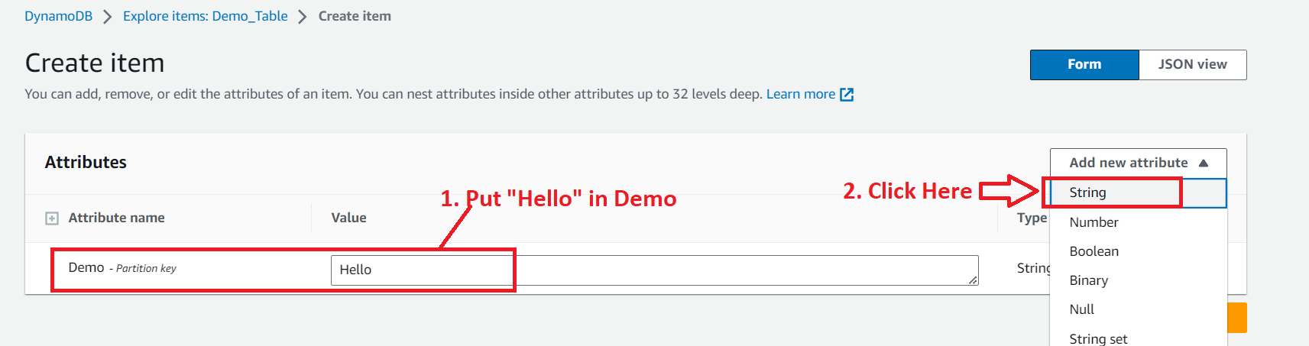

**Step 18:** **We** will put “**Attribute”** as **“Emp_Name”** & **the “Value”** as “**John”**. **Click** on the “**Create Item”**.

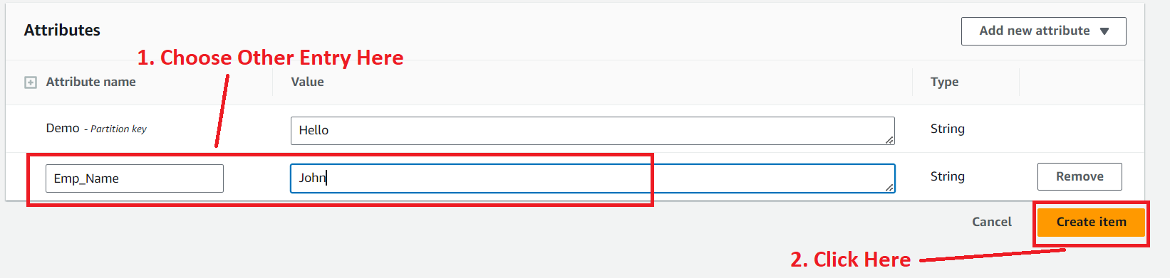

**Step 19:** Your **table items** will be **successfully created**. **You** can now **add other attributes** in **your tables** **as well**.

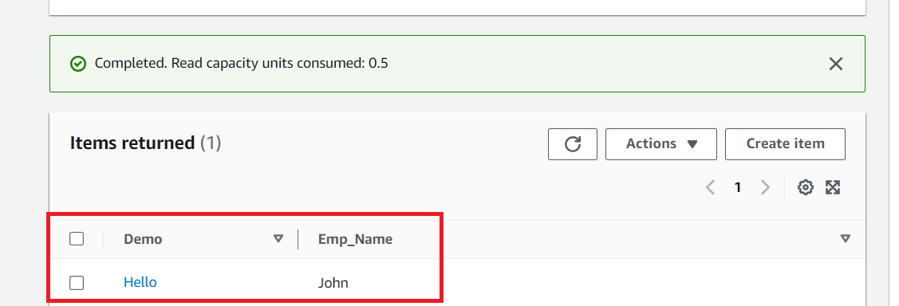

***So, this is the VPCDynamoDB role which will provide you all the access to use VPC & DynamoDB services. (Here, we have shown needed demo only.)***